**NBA MSSQLServer Build Guide**

**Section I - Building our sqlite database**

I - Download nba_sql_v0.0.9 (or latest) from

<https://github.com/mpope9/nba-sql/releases/tag/v0.0.9>

II- Open the .exe file, you should see something like this

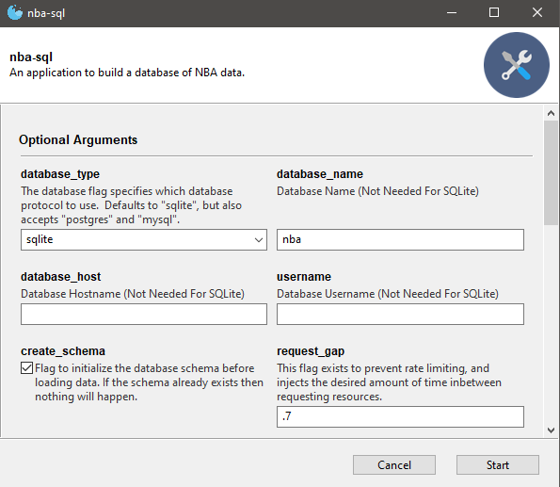

III- Parameters for Optional Arguments (if not mentioned, leave unchanged)

sqlite_path - Set to whatever you would like your database to be named

seasons - Select seasons you would like to include in database

So far, only 2022_23 will *verifiably* work with these instructions

Depending on seasons & tables selected, program won’t work*

skip_tables- Select tables you would like to skip over when pulling stats

Certain tables encounter repeated issues when pulling stats*

**Section II - Adding ODBC Data Source**

I - Download necessary ODBC driver from

<http://www.ch-werner.de/sqliteodbc/sqliteodbc.exe> or

<http://www.ch-werner.de/sqliteodbc/sqliteodbc_w64.exe> depending on system type*

SECOND LINK FOR 64x ARCHITECHTURE

II - In Windows search, type ‘ODBC’ and open the application that corresponds with your

system type.*

*:If unsure of system type, search ‘About’ in Windows search and check your

system type under ‘Device Specifications’

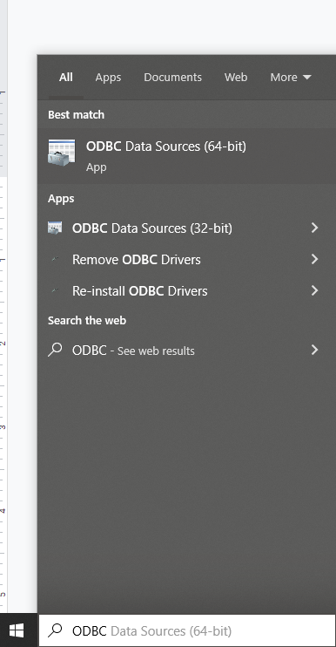



III - Click on the ‘System DSN’ tab, then click the ‘Add…’ button.

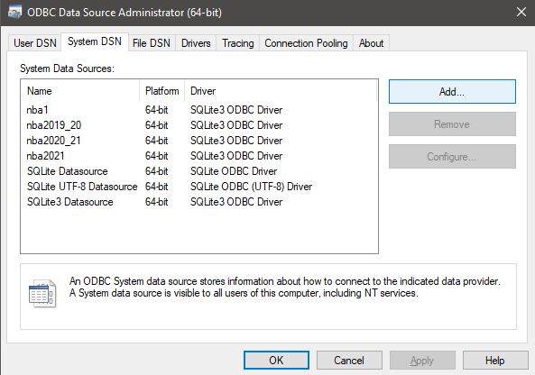

IV - Select ‘SQLite3 ODBC Driver’ then click ‘Finish’

V - Set configuration to pictured or similar, click ‘OK’

‘Data Source Name’ can be anything, but mine pictured will be nba1 throughout

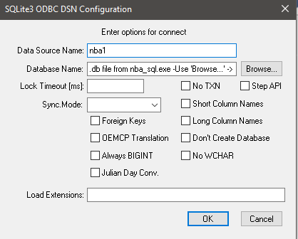

VI - Restart computer here if you would like

**Section III - Adding Linked Server IN MSSQLServer**

I - Open MSSQL Server, open a new query and execute the following Query

USE [master]

GO

EXEC sp_addlinkedserver

@server = 'nba', -- The name you give the server in SSMS

@srvproduct = '', -- Can be blank but not NULL (most occasions to be left blank)

@provider = 'MSDASQL',

@datasrc = 'nba1' -- The name of the System DSN connection you created

GO

CREATE DATABASE nba -- Replace nba with whatever you’d like to name the database

GO

**Section III - Manipulating Database**

**The ‘build.sql’ file has only been verifiably confirmed as working with the**

**2022_23 season and by skipping the play_by_play and shot_chart_detail tables.**

I - Open ‘build.sql’ and execute the query

**Section X - Tables explained**

**Table: team_season**

**Column Description**

**season_id - Links table to a specific season**

**team_id - Links table to specific team**

**avgage - Average age of team for that season**

**avgheight - Average height…………………………**

**ppg - Points scored per game by specific team in specific season**

**apg - Assists registered per game by specific team in a specific season**

**orbpg - Offensive Rebounds per game by a team in a season**

**drbpg - Defensive Rebounds per game by a team in a season**

**rbpg - Rebounds per game by a team in a season**

**fgs - Field Goals/Field Goals Attempted per game by a team in a season**

**fgpct - Field goal percentage by a team in a season**

**fg3s - 3ptFG/3ptFG Attempted per game by a team in a season**